Call for Participation
The 16th NAPROCK International Programming Contest, Nara, Japan
(NAPROCK PROCON 2024)
“Technology Blossoming in the Heat of MAHOROBA"
Organizer: Federation of National Colleges of Technology
Co-host: NAPROCK
Supporters: (tentative)
Ministry of Education, Culture, Sports, Science and Technology / Ministry of Internal Affairs and Communications / Ministry of Economy, Trade and Industry / National Police Agency / Digital Agency / Nara Prefecture / Nara Prefectural Board of Education / Nara City / Nara City Board of Education / Yamato-koriyama City / Yamato-koriyama City Board of Education / Nara Prefectural Federation of Chamber of Commerce and Industry / Software Association of Japan / Information Processing Society of Japan / The Institute of Electronics, Information and Communication Engineers / The Japan Society for Information and Systems in Education / National Institute of Information and Communications Technology / Digital Region Development Organization / Nara Prefectural Industrial Technology Center / IT Junior Development Exchange Association / NHK / Nara Television / The Nara Shimbun / The Asahi Shimbun / The Mainichi Shimbun / The Nikkan Kogyo Shimbun / National Institute of Technology, Nara College, Supporters Association / National Institute of Technology, Nara College, Alumni Association
Sponsors:
Over 50 companies including Advanced Planning Corporation, ISB Corporation, Cosmo Research Co., Access net Inc., NTT Comm Engineering Corporation , FIXER Inc., LY Corporation
Host Organization: National Institute of Technology, Nara College
Secretariat: Division of Student Affairs, National Institute of Technology, Nara College
PROCON official website: https://www.procon.gr.jp/
Referees: 40 judges with OBA Michiko (Kyoto Tachibana University) as the president of judges.

Introduction
In the 16th NAPROCK International Programming Contest (NAPROCK PROCON 2024), attending students will make use of the results of their daily studies to compete in ideas for information and communication technologies and in abilities to realize those ideas. This year's competition will be divided into three divisions: "Themed Section," "Original Section," and "Competition Section”. This is an excellent opportunity for students to show their abilities to the world. We encourage them to develop original ideas that students can come up with, and to take challenge in creating works that make full use of information and communication technology, which has been developing remarkably in recent years. The contest consists of a preliminary round and a final round. In the preliminary selection process, we evaluate the originality of the idea. The work may be incomplete when entering for the preliminary selection, but it must be feasible.
The contest has been highly acclaimed by various circles for the flexibility and the high level of the ideas that are submitted to the contest. It has also been widely covered by the mass media and has attracted attention as a project for creativity education. Furthermore, the contest can be considered as a venue for international exchange with Japanese KOSEN students in the competition of information processing techniques.
This contest is supported by many co-sponsoring and supporting organizations including the Ministry of Education, Culture, Sports, Science and Technology (MEXT), and sponsoring companies.

Date and Venue

- Application period:
May 20, 2024, 8:30 am (JST) to May 27, 2024, 5:00 pm (JST)
- Preliminary Rounds (document screening): June 22, 2024

- Qualification Results:
The results will be announced in MS Teams and/or by e-mail in late June.
- Final Rounds (details will be sent separately to those who pass the preliminary round) :
Date: October 19 to 20, 2024
Venue: Nara Centennial Hall (7-1 Sanjo-Miyamae-cho, Nara City)

Eligibility for Application
- Japanese KOSEN students (including advanced course students)
- students in foreign KOSENs/universities/institutes

Sections for Application
(For details of each division, please refer to the information for each category and official website.)
Applications will be accepted for each technical college (campus) as follows

Themed Section | 2 teams or less | Each team should consist of 2 to 5 student members
Original Section | 2 teams or less | Each team should consist of 2 to 5 student members
Competition Section | 1 team | Each team should consist of 2 to 3 student members

Please submit one entry per team. Duplicate registration of students is prohibited. In other words, the same student cannot belong to more than one team. Mixed teams consisting of students from multiple schools (including multiple campuses) are not allowed.
No changes will be allowed in the registration of the themed and original secctions once the team applies. Students who have NOT registered at the time of application (supporting students, etc.) will be treated the same as general participants and will not be allowed to give explanations of their works at the demonstration or presentation.
For the competition section, changes in the registered students after the preliminary rounds are allowed, but not in the teachers.

Works that can be applied
Software that can be executed on personal computers, tablets, etc., and can be demonstrated or presented at the venue of the final round or can participate in the competition.
However, since the preliminary round is a document review, you may apply even if you only have the idea for your system. In other words, you may complete your system after passing the preliminary round.

How to apply
It will be available on the PROCON official website or by e-mail later.

Judging method
This contest will be held in two stages, the preliminary and final rounds. Throughout the preliminary and final rounds, we will emphasize on evaluation the rich creativity of the students.

Preliminary screening method
1. The preliminary screening will be conducted based on the PDF files submitted in accordance with the application guidelines.
2. 5 foreign teams each will qualify for all of Themed, Original and Competition Section. Qualification will be determined for each section according to the evaluation. The preliminary rounds will focus on the originality of the entries. The entries will also be evaluated according to their usefulness and feasibility.
3. For the Themed Section, entries will be judged on their appropriateness to the designated theme of the contest.
4. In the Competition Section, entries will be evaluated based on the quality of the ideas and the feasibility of the solution algorithms for the assignments described in the entry form. In case the entry is insufficient or inadequate, it may not pass the preliminary round.

Judging Method for the Final Round
The teams that pass the preliminary round will compete in the final round.
1. Themed Section and Original Section
The works will be judged comprehensively by the presentation and the demonstration. Judging criteria include originality, usefulness, operability, technical skills in system development, creation skills for operation instructions, and presentation skills (presentation and documentation skills). Students who are not registered at the time of application (supporting students, etc.) will be treated the same as general participants and will not be allowed to give explanations of their works at the presentation or demonstration.
The operation instruction and program source list are also subject to judging. Teams participating in the final round are required to submit the operation instructions and program source lists prior to the final round. Details on how to submit these documents will be announced separately to the teams that qualify for the final round after the preliminary round.

2. Competition Section
The winner will be determined by a competitive match.
Special prizes will be decided comprehensively based on the system outline, program source list, user interface of the competition program, and detailed system description. The system declaration form, program source list, and detailed system description must be submitted prior to the final round. Details on how to submit these documents will be announced separately to the teams participating in the final round after the preliminary round.

Prizes
The following prizes will be given in both the Themed Section and the Original Section:
Grand Prize: 1 team
Second Prize: 1 team
Special Prize: several teams
The following prizes will be given in the Competition Section:
Champion: 1 team
First Runner-up Prize: 1 team
Special Prize: several teams

Notices
1. Completeness of the system
Teams selected for the final round should make every effort to realize their ideas from the preliminary round. Please note that teams that do not fully realize their ideas from the preliminary round may be eliminated from the competition.

2. Transportation expenses
The organizer will provide transportation and accommodation expenses for those who participate in the final rounds under certain conditions. Details will be announced separately to the teams participating in the final round after the preliminary round.

3. System transportation
The cost of transporting the systems necessary for the demonstrations and competitions in the Original Section and the Themed Section in the finals is to be borne by the participants.
Please note that the organizer will not provide the teams with a computer.
4. Demonstration exhibition space and internet access for the Themed and Original Sections
The exhibition space for the contest is limited to 1800 mm * 1500 mm * 210 cm (width * depth * height) for each system and the exhibitor. An identification tag printed on A4 paper will be attached to the upper left corner of the panel so please do not cover it up with the system. Up to two desks will be available for use. Details will be posted on the PROCON official website and MS Teams, so please make sure that your system fits within the regulations.

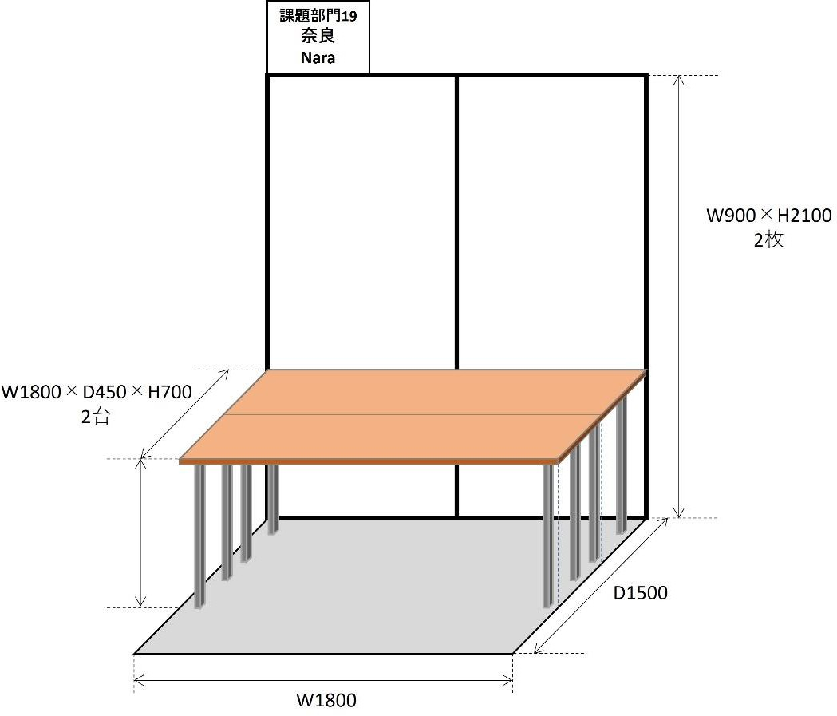
In this contest, we will not provide wired internet connection. Wi-Fi access point will be provided in the venue, but you may not be able to acquire the necessary communication. Therefore, if you wish to conduct a demonstration that requires an Internet connection, each team should prepare its own communication means. Even if a communication device has been set up, there is a possibility that communication may be unstable depending on the location of the booth. Therefore, even if you cannot connect to the Internet, please be prepared to work with dummy data.
Power at the demonstration site is assumed to be 500W for each booth. Power outages, voltage dips, and other problems can cause inconvenience to surrounding teams. If you expect excessive or fluctuating power consumption, such as by using high power-consumption computers or high-power motors, please prepare your own power supply by renting a battery power supply or other means.

5. Intellectual property rights, etc.
When submitting your work, please be careful not to infringe on the intellectual property rights of others and take necessary care to protect your own intellectual property rights.
The copyrights to the submitted works are owned by the applicants, but the following materials may be used in the video recordings, official websites, brochures, and other media. These materials may also be used for educational purposes.
(1) Documents and files submitted at the time of application (work explanation, application contents files)
(2) Documents and files to be submitted for the final round (brochure manuscript, operation manual, system overview, detailed system description, team introduction video file, etc.)
(3) Photographs, videos and presentation data taken during the final rounds
(4) Competition response data submitted at the time of the final round

6. Entry to similar contest
Entries must be original. Entries that have been submitted to other contests of the same type are not accepted. However, improved versions of previous entries that did not pass the preliminary rounds may be submitted.

7. Inquiries
Inquiries should be directed to the following e-mail address or MS Teams. Responses to inquiries will be posted on MS Teams as they become available. Please keep in mind that your question will be made public.

Contact email address: procon@naprock.jp
Please be sure to make inquiries through your teacher.
Related Sites
PROCON official website: https://www.procon.gr.jp/
Official PROCON Twitter account: @KosenProcon
Official Facebook page of PROCON: https://www.facebook.com/KosenProcon/
NAPROCK International PROCON official website: https://www.naprock.jp/intprocon/
Digital Days Website: https://digital-days.digital.go.jp/

The 16th NAPROCK International Programming Contest, Nara, Japan

Themed Section

“Solving Environmental Problems Using ICT”

Overview of Themed Section

According to the Intergovernmental Panel on Climate Change (IPPC), the average annual temperature will increase by 1.5 degrees Celsius in 2030 compared to the pre-industrial era (*1). Climate change caused by global warming has resulted in major disasters such as record-breaking torrential rains, large typhoons, and heavy snowfalls in winter due to the Japan Sea polar airmass convergence zone (JPCZ). In addition, changes in the marine environment caused by rising temperatures have led to a sharp decline in amount of fishery, and there are concerns about the depletion of marine resources (*2). The effects of environmental destruction and global warming are becoming more serious every year, and we are becoming more familiar with their effects. We have reached a situation where environmental issues must be addressed "with no wait.”
Against this background, the Japanese government has been promoting the introduction of renewable energy, the diffusion of energy-saving technologies, and the reduction of carbon emissions. The GXI has declared its goal of achieving carbon neutrality, a state of zero greenhouse gas emissions by the year 2050 and has placed emphasis on environmentally friendly economic development (Green Transformation; GX), including the reduction of greenhouse gas emissions. In order to promote such activities, a robust digital infrastructure is required (*3), and it is clear that the use of ICT is a prerequisite.
On the other hand, it is important for governments, companies, as well as individuals and communities to engage in various activities related to environmental issues. For example, promoting the use of EVs, bicycles, and public transportation, energy-saving activities at homes and schools, reduction of food loss, forest protection and afforestation, recycling and proper disposal of waste, etc. are representative examples, and education and awareness-raising for environmental issues are also important. Such activities may be achieved more effectively by actively utilizing ICT.
The Themed Section of the 16th NAPROCK International Programming Contest invites entries aimed at "solving environmental problems by utilizing ICT.” Environmental problems cover a wide range of issues from the immediate surroundings to society as a whole. We hope that the creative ideas of students will contribute to the realization of a sustainable global environment.

*1 Ministry of the Environment: Intergovernmental Panel on Climate Change (IPCC) Sixth Assessment Report (AR6) Cycle
https://www.env.go.jp/earth/ipcc/6th/index.html
*2 COOL CHOICE: The Taste of the Season in Crisis? Global warming and choosing "local production for local consumption" https://ondankataisaku.env.go.jp/coolchoice/weather/article03.html
*3 Cabinet Secretariat et al: "Green Growth Strategy for 2050 Carbon Neutrality”
https://www.meti.go.jp/press/2022/02/20230210002/20230210002_1.pdf

Notices

- You are free to use peripheral devices creatively, but it will be evaluated whether you are using them effectively in your programming or not. Please make sure that it fits into the exhibition space. In addition, for the final competition, you must be able to complete the installation within the allotted time (approximately 40 minutes).
- It will be evaluated if the work matches with the theme given for the section.
- The originality of the work is placed the highest priority in the judgement, but the usefulness, feasibility (method of realization), and degree of completion of the work as well as the programming techniques will also be subject to evaluation.

The 16th NAPROCK International Programming Contest, Nara, Japan

Original Section
Overview of Original Section
The Original Section of the 16th NAPROCK International Programming Contest invites computer software that are created by the open and creative minds of the applicants.
Smartphones and tablets have become widespread, and new devices such as wearable computers have appeared. In addition, the environment surrounding the Internet is changing dramatically with cloud computing, open data utilization, and the need for cyber security, and our lives are about to change dramatically. How should open data and ICT technologies be utilized over all the changing elements such as where we work, where we line and where we relax, day and night, in different seasons, and in different times?
It has the potential to dramatically solve many of today's problems, such as education, ecology, food issues, telemedicine, and the new normal ushered in by infectious diseases.
In the Original Section, we are looking for creative works that are not bound by conventional frameworks, but are devised with free ideas in this social context. We are looking forward to seeing works full of originality unique to students.

Notices

- You are free to use peripheral devices creatively, but it will be evaluated whether you are using them effectively in your programming or not. Please make sure that it fits into the exhibition space. In addition, for the final competition, you must be able to complete the installation within the allotted time (approximately 40 minutes).
- The originality of the work is placed the highest priority in the judgement, but the usefulness, feasibility (method of realization), and degree of completion of the work as well as the programming techniques will also be subject to evaluation.

The 16th NAPROCK International Programming Contest, Nara, Japan

Competition Section

Shin “World Heritage Revival”

Overview of Competition Section
This year's competition will be based on the motif of restoring cultural properties. Nara Prefecture is one of the places in Japan where many World Heritages are found. The Buddhist architecture in the Horyu-ji area were the first in Japan to be designated a World Heritage Site in 1993.
In addition, the cultural properties of the ancient capital of Nara were enlisted in the World Heritage in 1998 and Sacred Sites and Pilgrimage Routes in the Kii Mountain Range followed in 2004. However, among these precious cultural properties, there are many that have deteriorated or have lost its original vivid colors due to natural and man-made disasters, or by being exposed to wind and rain over an extended period of time. In addition to protecting these cultural properties, restorations have been carried out in many places to bring them back to the original state in every detail. We owe to the wisdom and efforts of our predecessors that we can actually see these gems that have been restored over time.
Therefore, taking from the theme “World Heritage Revival” which was used for the 3rd NAPROCK International Programming Contest 2011 in Maizuru in Kyoto, the neighboring prefecture of Nara, also rich in World Heritage sites, we have set this year’s theme to: "Shin Revive World Heritage".
In the competition, a board consisting of several pieces (the cultural property before restoration) and several dies (restoration tools) are prepared at the beginning. When the die is applied to the board, the pieces that match the die are removed, and the missing pieces are filled in from either the top, bottom, left or right direction. Use the die effectively to make the board into the final state (the restored cultural property). The team that "restores" the cultural asset as quickly as possible in the fewest number of moves wins the competition.

Board and Die Cutting
- The components of a board are called pieces, and the pieces are arranged in a rectangle to form the board. The maximum board size (number of pieces) is 256 both vertically and horizontally and the minimum is 32. The vertical and horizontal configurations are not necessarily the same. The board size differs according to the assignment.
- The piece is assigned an integer value from 0 to 3.
- Each value from 0 to 3 is assigned to at least 10% of the total pieces.
- The components of a die are called cells, which are arranged in a rectangle to form the die. The maximum size (number of cells) of the die is 256 cells and the minimum is 1 cell. The vertical and horizontal configurations are not necessarily the same. The size of the die differs according to the assignment.
- Cells are assigned the value 0 or 1. There are no dies that have only cells assigned 0, but there is no restriction in the ratio of cells assigned 1 or 0.
- Figure 1 shows an example of the coordinate system for a board and a die. The smallest board size used in the competition is 32 x 32, but a smaller board is shown for illustration.
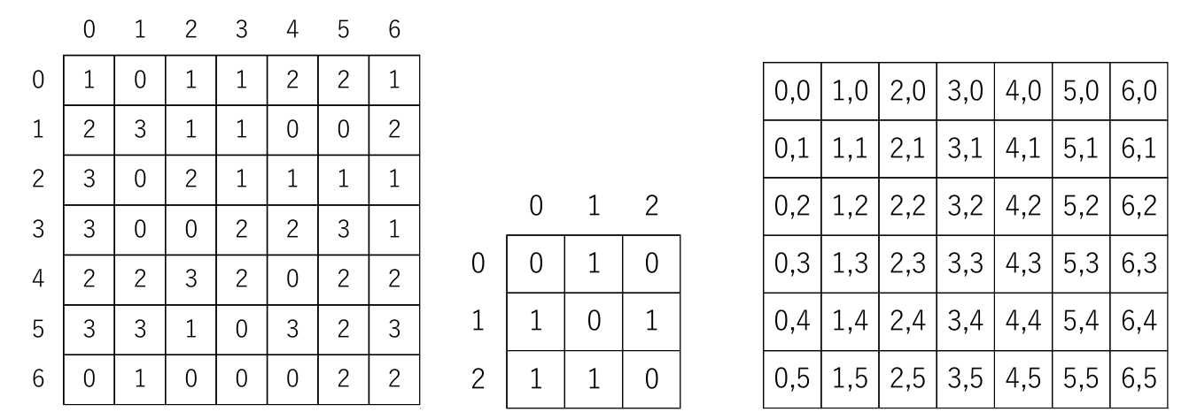
Board Die Coordinates of board and die
Figure 1: Example of Board and Die Cutting.

Die Cutting
- Applying a die to an area of a board is called "die-cutting" and each die-cut is counted as a "move".
- The same die can be used to die-cut multiple times.
- In die cutting, the following operations are performed on the board in the following order.
- Pull out the piece of board corresponding to the cell with the value of 1 in the die-cut from the board.
- Move the remaining pieces on the board towards the specified direction.
- Put the pieces removed in (1) back in the original order in the empty space.
- Die-cutting can be applied to any position on the board. The die can extend beyond the board if part of the die-cut is on the board.
- The part of the die that is not overlapping with the board has no effect on the die cutting.
- The die cutting position is indicated by the coordinates of the board to which the upper left cell of the die is applied. If the position must be outside the board because it is above or to the left of the board, it is expressed as a minus coordinate.
- The direction of movement can be up, down, left, or right.
- Figure 2 shows an example of die cutting. This is an example of applying to (1, 2) on the original board with the die in Fig. 1 and pulling it to the left and to the right. It can be die-cut in the same way in the vertical direction.

Assignment
- A single assignment consists of the original board, the final state of the board and several die cuts.
- The initial and final board sizes are the same and have the same number of pieces assigned the same value.
- The die is available in the three types as shown in Fig. 3, and there are 9 types based on the vertical and horizontal sizes of 1, 2, 4, 8, 16, 32, 64, 128, 256, which makes total of 25 dies (since size 1 will be the same for all three types). These dies are called “fixed dies” and always included in the assignment. Other types of dies are called “general dies.”
Type I: All cells are 1
Type II: Cells in even-numbered rows are 1 and cells in odd-numbered rows are 0
Type III: Cells in even-numbered columns are 1 and cells in odd-numbered columns are 0

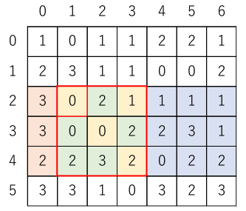
Original board and die-cut position

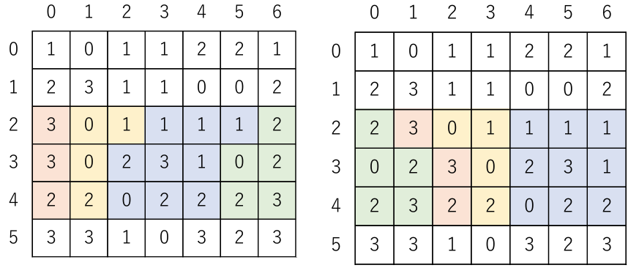

Die cutting by moving to the left Die cutting by moving to the right
Figure 2: Example of Die Cutting.

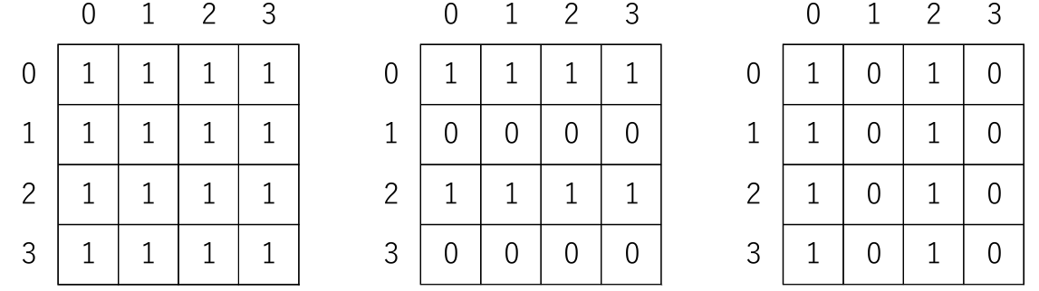

Type I Type II Type III
Figure 3: Example of fixed dies (size 4).

- The dies are numbered, starting from number 0 in the order of the fixed dies and then, the general dies. In other words, the general die starts from number 25.
- The fixed dies are numbered from smallest to largest: size 1 is number 0, size 2 type I, type II and type III are numbers 1, 2, and 3, respectively, and size 256 type I, type II, and type III are numbers 22, 23, and 24, respectively.

Assignment format
- In each assignment, the data for the initial and final states of the board and general die are given in JSON format as follows. The fixed die is not included in the assignment format.
- The board information is recorded in the "board" key. Information for the general die is recorded on the "general" key.
- For the board information, the width and height of the board is recorded in the "width" and "height" keys, and the initial and final states in the "start" and "goal" keys. The values of the initial and final state pieces are recorded consecutively, one per line.
- For the general dies, "n" key is used to record how many general dies there are, and the "patterns" key is used to record the information of each general die.
- The "p" key records the number given to the general die, the "width" and "height" keys records the width and height of the die, and the "cells" key records the value of the cell. The cell values are recorded consecutively, one per line.
- Figure 4 shows an example of assignments. An example of the assignment data in this case is also shown in Fig. 5.

1 | 0
0 | 1

0 | 1 | 1 | 1
1 | 0 | 0 | 1

0 | 0 | 0 | 0 | 0 | 0
1 | 1 | 1 | 2 | 2 | 2
2 | 2 | 2 | 2 | 3 | 3
3 | 3 | 3 | 3 | 3 | 3

2 | 2 | 0 | 1 | 0 | 3
2 | 1 | 3 | 0 | 3 | 3
0 | 2 | 2 | 1 | 0 | 3
3 | 2 | 2 | 0 | 3 | 3

Initial state Final state General Die General Die

Figure 4: Assignment Example.

Response Format
- Please record the die information for the answer in JSON format data as described below:
- Record the number of moves in "n" key.
- In the “ops" key, record the die information in order from the first move.
- One die-cutting information consists of die number, X coordinate applied, Y coordinate applied, and the direction of move (this consists of four elements; top:0, bottom:1, left:2, right:3) and these four values are each recorded in "p", "x", "y", and "s" keys).
- If the number of moves indicated and the number of die information are not consistent, that answer will be considered invalid.
- Other responses that do not conform to the format will be considered invalid.
- An example of an answer is shown in Fig.6. This example shows a 3-move solution where the first move is to apply die 4 to (5, 6) and to move to the left direction; the second move is to apply die 11 to (3, -12) and move to the right direction; and the third move is to apply die 25 to (6, 0) and move towards the up direction.

{
"board": {
"width": 6,
"height": 4,
"start": [
"220103",
"213033",
"022103",
"322033."
],
"goal": [
"000000",
"111222",
"222233",
"333333"
]
},
"general": {
"n": 2,
"patterns": [
{
"p": 25,
"width": 4,
"height": 2,
"cells": [
"0111",
"1001"
]
},
{
"p": 26,
"width": 2,
"height": 2,
"cells": [
"10",
"01"
]
}
]
}
}
Figure 5: An example of data format for the assignment shown in Fig.4.

{
"n":3,
"ops":[
{
"p":4,
"x":5,
"y":6,
"s":2
},
{
"p":11,
"x":3,
"y":-12, "s":3
},
{
"p":25,
"x":6,
"y":0,
"s":0
}
]
}

Figure 6: An example of the response formats.

Progression of the match
  - A match is played by several teams at the same time. The number of teams will vary depending on the combination of teams.
  - The number of teams for each match will be announced in the additional documents released after the preliminary round.
  - One assignment is given for one match.
  - A time limit will be set for each match. The time limit is expected to be about 5 minutes.
  - The size of the board and the number and size of dies are not necessarily the same for each assignment.
  - The size of the board and the number and size of dies will be announced prior to the start of the game.
  - The assignments will be provided via the network as soon as the game starts.
  - Each team solves an assignment within the time limit and submits the answer via the network.
  - When the server receives the answers sent from each team, it will receive information on whether they were successfully accepted or invalid (format error).
  - The answer can be re-submitted if it is within the time limit, however, if the number of times or volume of submissions is so large that it interferes with the progress of the game, it will be considered an act of sabotage, and the team may be disqualified.
  - The last response received will be valid.

Deciding on the winner
The winners will be determined by the following order of priority: based on the degree of agreement, number of moves, and response time.
- The team with the fewest pieces in disagreement with the final state wins.
- The team with fewer moves wins.
- The team that submitted the final response the fastest wins.
- The winner is decided by dice or considered a draw.

Communication Method
- Each team's PC will be connected to the wired LAN in the competition booth and will be able to send and receive data using the http POST/GET format.
- Detailed information on the communication protocol and response system will be available on the PROCON official website as well as MS Teams around the beginning of July.

Notices
- No more than three portable and programmable computers may be brought to the competition. At least one of these devices must have a 10BASE-T/100BASE-TX/1000BASE-T RJ45 wired LAN port and TCP/IP connectivity to submit the answer.
- Each team will have at least 4 power outlets in the competition booth. Please do not exceed the total power of 500W.
- Each team will be provided with one LAN cable to connect to the competition network. Each team must provide their own equipment such as switching hubs if necessary to connect multiple computers to the competition network.
- Wireless communication by Bluetooth or other means between devices you bring in is acceptable, but Wi-Fi communication is not permitted.
- During the competition, information may be exchanged within the team, but no information may be exchanged with anyone outside the team. Communication with devices other than the team’s device is not permitted.
- Act of interference with the server or other team’s match progress is not allowed. Players may be disqualified if they are found to be obstructing the match progress, interfering with the referees or members of other teams, or committing any other prohibited acts.
- Data transmission and reception over the network may be handled offline in the event of a system failure on the part of the organizer. In such cases, the match time may be changed.
- In case of any trouble on the organizer's side, there is a possibility that the game will be rescheduled with a different assignment.
- The data used in the competition and the data sent to the server by each team may be published on the PROCON official website after the competition.
- During the competition, the players and their desk areas (computer screens, operation status, notes on desks, etc.) may be photographed or recorded by video cameras, etc., and simultaneously displayed on the screen, etc.
- During the competition, the referees may examine the players and their desk areas (computer screen, operation status, and notes on desks) for judging purposes.

Inquiries
Inquiries should be directed to the following e-mail address or MS Teams. Responses to inquiries will be posted on MS Teams as they become available. Please keep in mind that your question will be made public.

Contact email address: procon@naprock.jp
Please be sure to make inquiries through your teacher.

